Challenges and Impacts of Online Education in Different Regions of China

Your Name, Education Studies, University of Warwick



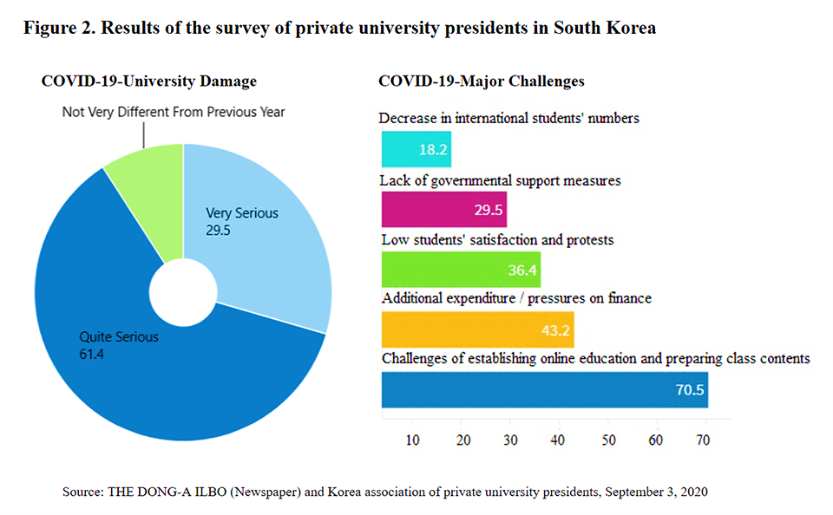

What we know already
Research on the challenges and impacts of online education in different regions of China has identified a number of factors that influence the success of online education initiatives. Here are some of the key findings:
Unequal access to technology: One of the biggest challenges of online education in China is unequal access to technology, especially in rural and underdeveloped regions. Many students lack access to computers or high-speed internet, which can limit their ability to participate in online classes.
Language barriers: China has many different dialects and languages, and online education initiatives can face challenges in providing materials in a way that is accessible to all students. This is particularly true for students who speak minority languages, such as Tibetan or Uyghur.

Lack of teacher training: Many teachers in China have limited experience with online education platforms, which can make it difficult to deliver effective online classes. Providing training for teachers can help to address this challenge.

Cultural attitudes: Some parents and students in China still prefer traditional classroom-based education, and may be hesitant to adopt online education initiatives. Additionally, online education may not be viewed as prestigious as traditional education, which can discourage some students from participating.

Infrastructure challenges: In addition to access to technology, some areas of China lack reliable electricity or internet access, which can make it difficult to deliver online classes.

Educational inequality: While online education has the potential to help reduce educational inequality, research has shown that some students may be at a disadvantage in online environments. For example, students from low-income families or with limited access to technology may struggle to keep up with their peers

How this will be carried out
The reaseacrh will conducted using Surveys and questionnaires. Researchers will use surveys or questionnaires to gather data on students' and teachers' experiences with online education. These surveys will major on topics such as access to technology, challenges with online learning, and overall satisfaction with online education
This study will use purposive sampling to select participants from different regions of China. The study will select 50 participants from each region, including 25 teachers, 25 students, and 10 education officials. The study will select participants based on their experience with online education. Participants will be selected from various regions of China to ensure diversity in the sample.

My project is about
Online education has become increasingly popular in China, particularly during the COVID-19 pandemic. Online education has played a crucial role in bridging the education gap in remote and underdeveloped regions. However, the challenges and impacts of online education in different regions of China are not well documented. This study aims to investigate the challenges and impacts of online education in different regions of China.

What this research contributes
This research can contribute to our understanding of the opportunities and limitations of online education in a diverse and complex educational context. This type of research can provide valuable insights into the specific challenges that students and teachers face in different regions of China, and how these challenges are shaped by cultural, economic, and social factors.
Source (World Economic Forum, 2023)

Contact Details

Challenges and Impacts of Online Education in Different Regions of China
Your Name, Education Studies, University of Warwick

This study will use a comparative research design to investigate the challenges and impacts of online education in different regions of China. The study will collect both qualitative and quantitative data. The data will be collected through semi-structured interviews with teachers, students, and education officials and an online survey.
The research questions will be developed to address the specific challenges and impacts of online education in different regions of China. For example, what are the challenges that students and teachers face in using online education platforms in different regions of China? How do cultural, economic, and social factors impact online education outcomes in different regions of China?

Online education has emerged as an increasingly popular mode of learning in China, particularly in the wake of the COVID-19 pandemic. While online education offers many potential benefits, such as increased flexibility and access to resources, it also poses significant challenges and has wide-ranging impacts on education outcomes. This research aims to investigate the challenges and impacts of online education in different regions of China.

Topic/Intro/Background
Research Design
Literature
This research aims to explore these challenges and impacts in greater depth by studying online education in different regions of China. Specifically, the research will investigate the experiences of students and teachers in different regions of China with online education platforms, including the challenges they face and the opportunities they see. The research will also analyze the impact of online education on education outcomes, including academic achievement and social mobility, in different regions of China.

Discusion on the instroduction to challenges and impacts of online education in regions of China

Warwick Logo
Online education has gained significant attention in recent years, particularly in the context of the COVID-19 pandemic. The literature review will focus on the current state of online education in China, the challenges faced by different regions, and the impact of online education on student learning outcomes. The review will also explore the importance of online education in providing equitable access to education in China.

